header{
height: 13v;
background-color: aqua;
display: flex;
justify-content: space-between;
}

ul li{
display: inline;
text-decoration: none;
padding: 12px;
}
#div1{
background-color: red;
}
.card{
background-color: green;
color:blue
}
input:hover{
background-color: yellow;
}
.container{
display: flex;
justify-content: space-around;
margin-top: 40px;
}
.card{
width: 23%;
height: 30vh;
border: 2px solid black;
border-radius: 15px;
padding: 10px;
display: flex;
flex-direction: column;
align-items: center;
box-shadow: 10px 5px 5px red;
background-color: ghostwhite;
}
div>img{
width: 80%;
height: 80%;
border-radius: 15px;
box-shadow: 5px 5px 5px black;
}
footer{
display: flex;
justify-content: center;
height: 10vh;
background-color: aqua;
bottom: 0;
position: absolute;
width: 99%;
align-items: center;
}
#herounit{

height: 20vh;
width: 99vw;
}
#herounit>img{
width: 100%;
height: 100%;
object-fit: cover;
}

<!DOCTYPE html>
<html lang="en">
<head>
<meta charset="UTF-8">
<meta name="viewport" content="width=device-width, initial-scale=1.0">
<title>Document</title>
<link rel="stylesheet" href="styles/style.css">
</head>
<body>
<header>
<h2>Cognizant </h2>
<ul>
<li >Login</li>
<li >register</li>
<li>Profile</li>
</ul>
</header>
<div id="herounit">
<img src="images/trees.jpg" alt="">
</div>

<main class="container">
<div class="card">
<img src="images/img1.jpg" alt="">
</div>
<div class="card">
Info 2
<img src="images/img1.jpg" alt="">
</div>
<div class="card">
Info 3
<img src="images/img1.jpg" alt="">
</div>
</main>

<footer>
All rights reserved &reg; copyright Congnizant &copy; &nbsp; 2024
</footer>
</body>
</html>

.container{
display: grid;
width: 99%;
height: 97vh;
grid-template-areas: "header header header header"
"sidebar main main adbar"
"sidebar main main adbar"
"sidebar main main adbar"
"sidebar main main adbar"
"sidebar main main adbar"
"sidebar main main adbar"
"footer footer footer footer";
}
header{
background-color: cadetblue;
display: flex;
justify-content: space-between;
align-items: center;
}
ul li{display: inline;padding: 13px;}

@media (max-width: 768px) {
.container{
grid-template-areas: "header header header header"
"main main main main"
"main main main main"
"sidebar sidebar sidebar sidebar"
"adbar adbar adbar adbar"
"footer footer footer footer";
}
header{
flex-direction: column;
}
ul li{display: block;}

}

bootstrap.html
responsive design using bootstrap
==================
<!DOCTYPE html><html lang="en"><head><meta charset="UTF-8"><meta name="viewport" content="width=device-width, initial-scale=1.0"><title></title><link href="node_modules/bootstrap/dist/css/bootstrap.min.css" rel="stylesheet" integrity="sha384-sRIl4kxILFvY47J16cr9ZwB07vP4J8+LH7qKQnuqkuIAvNWLzeN8tE5YBujZqJLB" crossorigin="anonymous"></head><body><div class="container-fluid"><header class="row"><h3 class="col-md-4 col-sm-12 bg-primary">Swiggy </h3><ul class="col-md-8 bg-secondary"><li class="btn btn-sucess">Login</li><li>REgister</li><li>Show orders</li><li><button class="btn btn-primary">Contact Us</button></li></ul></header><main class="row"><section class="col-md-3" style ="background-color: aqua;"></section><div class="col-md-6"><img src="..." class="card-img-top" alt="image"><div ><h5 >Card title</h5><p >Some quick example text to build on the card title and make up the bulk of the card’s content.</p><a href="#" class="btn btn-primary">Go somewhere</a></div></div><section class="col-md-3" style="background-color: burlywood;">section 3</section></main><footer class="row" style="background-color: lightgray;">Copyright © 2023 Swiggy. All rights reserved.</footer></div></body></html>

<!DOCTYPE html>
<html lang="en">
<head>
<meta charset="UTF-8">
<meta name="viewport" content="width=device-width, initial-scale=1.0">
<title>From</title>

</head>
<body>
<div>
<form id="myform">
<label for="name">First Name</label>
<input type="text" id="name" value="">
<label for="price">price</label>
<input type="number" id="price" value="">
<label for="Qty">Qty</label>
<input type="number" id="Qty" value=""><br>
<input type="submit" value="submit">
</form>
<table id="table1">
<tr>
<th>Name</th>
<th>Price</th>
<th>Qty</th>
</tr>

</table>
</div>
<script src="script.js"></script>
</body>
</html>

document.getElementById('myform').addEventListener('submit',(e)=>{
e.preventDefault();
let name = document.getElementById('name').value;
let price = document.getElementById('price').value;
let Qty = document.getElementById('Qty').value;
let table = document.getElementById('table1');
table.innerHTML += `<tr>
<td>${name}</td>
<td>${price}</td>
<td>${Qty}</td>
</tr>
`

})

<!-- how js handle parallel execution, it is not multi threaded? -->

<!DOCTYPE html>
<html lang="en">
<head>
<meta charset="UTF-8">
<meta name="viewport" content="width= , initial-scale=1.0">
<title>Document</title>
</head>
<body>
<div class="container">
<form action="">
<label for="id">ID
</label>
<input type="number" name="id" id="id">
<br><br>
<label for="price">Price
</label>
<input type="number" name="price" id="price">
<br><br>
<label for="qty">Quantity
</label>
<input type="number" name="qty" id="qty">
</form>
<br>
<button type="submit" onclick="addProducts()">Add</button>
<button type="submit" onclick="empty()">Cancel</button>
<br><br><br>
<div >
<table id="productsTable">
<tr>
<th>S.no</th>
<th>ID</th>
<th>Price</th>
<th>Quantity</th>
</tr>
</table>
</div>
</div>

<script>
let sno=1;
function addProducts(){
let id=document.getElementById("id").value;
let price=document.getElementById("price").value;
let qty=document.getElementById("qty").value;
// console.log("button clicked")
document.getElementById("productsTable").innerHTML+= `<tr><td>${sno++}</td><td>${id}</td><td>${price}</td><td>${qty}</td></tr>`
}

function empty(){
document.getElementById("id").value="";
document.getElementById("price").value="";
document.getElementById("qty").value="";

}

</script>
</body>
</html>

<!DOCTYPE html>
<html lang="en">
<head>
<meta charset="UTF-8">
<meta name="viewport" content="width=device-width, initial-scale=1.0">
<title>Document</title>
<script src="https://code.jquery.com/jquery-3.7.1.min.js" integrity="sha256-/JqT3SQfawRcv/BIHPThkBvs0OEvtFFmqPF/lYI/Cxo=" crossorigin="anonymous">

</script>
</head>
<body>
<center>
Name <input type="text" id="name"> <br>
Price <input type="text" id="price"> <br>
Qty <input type="text" id="qty"> <br>
<button id="btn" >Add</button>
<table border="1" id="table">
<thead>
<tr>
<td>Sl NO</td>
<td>Name</td>
<td>Price</td>
<td>Qty</td>
</tr>
</thead>
<tbody>

</tbody>
</table>
</center>
<script>
$('input[type="text"]').css(
{'background-color':'yellow',
'color':'blue','font-weight':'bold'})
$('table thead').css({'background-color':'blue','color':'white'})
$('button').css({'border':'2px dashed blue','color':'red','margin':'30px','width':'100px'})

$("#btn").click(function(){
let count = $("table tbody tr").length += 1
let bg = count % 2 == 0 ? "background-color: lightgreen;" : "background-color: lightcoral;";
let n = $("#name").val()
let p = $("#price").val()
let q = $("#qty").val()
let row = `<tr style="${bg}"">
<td>${count}</td>
<td>${n}</td>
<td>${p}</td>
<td>${q}</td></tr>`
$("#table tbody").append(row)
})
</script>
</body>
</html>

select * from Products p where 5=(
select count(distinct listprice)
from products pp where pp.listprice>=p.listprice)

select name,listprice,color,
dense_RANK() over ( order by listprice desc) as rank
from products

//dotnet skd 8 onewardsint[][] dd = [
[3,5,56,7,8],
[3,3,4,5,6,7,7,8,8,9]
];

for adding nuget package from vs code
go to command prompt from project folder
dotnet add package Microsoft.Data.SqlClient --version 6.1.4

One more sample question:
1. University Course Management System
You are tasked with building a University Course Management System in C# using object-
oriented programming principles. The application allows users to add, display, and update
details about different courses offered at a university.
Classes
Course Class
Represents a course with the following properties:
• CourseName (string): The name of the course.
• CourseID (int): A unique identifier for the course.
• Department (string): The department offering the course.
• Instructor (string): The name of the instructor assigned to the course.
• Credits (int): The number of credits assigned to the course.
Constructor:
public Course(string courseName, int courseId, string department,
string instructor, int credits)
Initializes course details.
Methods:
• public double CalculateDiscountedFee(double baseFee)
o Calculates the discounted fee for the course based on the number of credits.
o If Credits > 4, the fee has a 10% discount.
o If Credits >= 3, the fee has a 5% discount.
o If Credits < 3, there is no discount.
• public void DisplayDetails()
o Displays the details of the course, including the discounted fee.Custom Exception for Duplicate Course IDs
DuplicateCourseIDError Class
A custom exception thrown when attempting to add a course with an ID that already exists.
Constructor:
public DuplicateCourseIDError(string message)
Initializes the exception with the message: "Duplicate course ID error".
CourseManager Class
Manages course operations with the following features:
• courses: A list to store Course objects.
Methods:
• public void AddCourse(Course course)
o Adds a course to the collection.
o Throws DuplicateCourseIDError if the CourseID already exists.
o Displays "Course details added successfully" upon success.
• public void DisplayAllCourses()
o Displays details of each course in the collection.
o If no courses exist, prints "No courses available".
• public void UpdateCourseById(int id)
o Allows the user to select a course by CourseID and update its details.
o Displays "Course details updated successfully" after a successful update.
o If no courses exist or the CourseID is invalid, prints "Course not found".
Main Program
The program provides a menu-driven interface with the following options:
1. AddCourse
• Prompts the user to enter the details for a new course.
• Ensures CourseID and Credits are entered in the correct format.
• Calls AddCourse(Course course) in the CourseManager class.2. DisplayAllCourses
• Calls DisplayAllCourses() in the CourseManager class.
• Displays details of all added courses, including their general properties.
3. UpdateCourse
• Allows the user to select an existing course by CourseID.
• Prompts the user to enter updated details for the selected course.
• Calls UpdateCourseById(int id) in the CourseManager class.
4. Exit the Program
• Displays "Exiting the program..." and terminates the application.
Input format:
Choices
A single integer to choose an action:
1. Add a Course
2. Display All Courses
3. Update Course Details
4. Exit the Program
Adding a Course (Option 1):
Input the details for the new course:
• Course Name (string): The name of the course.
• Course ID (int): A unique identifier for the course.
• Department (string): The department offering the course.
• Instructor (string): The name of the instructor assigned to the course.
• Credits (int): The number of credits assigned to the course.
Ensures Course ID and Credits are entered in the correct format.
Validation and Success Message:
• Displays: "Course details added successfully" upon successful addition.• If Course ID already exists, throws DuplicateCourseIDError exception with
the message: "Duplicate course ID error".
Display All Courses (Option 2):
Input not required.
Output Format:
Displays details of all added courses, including their general properties:
"Course Name: {CourseName}, Course ID: {CourseID}, Department:
{Department}, Instructor: {Instructor}, Credits: {Credits},
Discounted Fee: {CalculateDiscountedFee(baseFee):F2}"
If no courses are available, prints: "No courses available".
Updating a Course (Option 3):
Input:
• Enter the Course ID corresponding to the course you want to update.
Provide updated details:
• Course Name (string): Updated course name.
• Department (string): Updated department name.
• Instructor (string): Updated instructor name.
• Credits (int): Updated credit value.
Validation and Success Message:
• Displays: "Course details updated successfully" after a successful update.
• If no courses exist or the Course ID is invalid, prints: "Course not found".
Exiting the Program (Option 4):
Displays "Exiting the program..." and terminates the application.

2. Book Management System
You are tasked with building a Book Management System in C# using object-oriented
programming principles. The application allows users to add, display, and update details
about different books in a library.
Classes
Book Class
Represents a book with the following properties:
• BookID (int): A unique identifier for the book.
• Title (string): The title of the book.
• Author (string): The name of the book's author.
• Status (string): The current condition of the book. Initially set to "New".
• Location (string): The shelf or section where the book is stored.
• BorrowCount (int): The number of times the book has been borrowed. Initially set to
0.
Constructor:
public Book(int bookID, string title, string author, string
location)
Initializes the book details.
Methods:
public void DisplayDetails()
Displays the details of the book, including the borrow count.
public void IncreaseBorrowCount()
• If BorrowCount < 5, the status remains "New".
• If BorrowCount <= 20, the status changes to "Used".
• If BorrowCount >= 20, the status changes to "Damaged".Custom Exception for Missing Book IDs
BookNotFoundException Class
A custom exception thrown when attempting to update a book that does not exist.
Constructor:
public BookNotFoundException(string message)
Initializes the exception with the message:
"Book with ID {bookID} not found".
LibraryManager Class
Manages book operations with the following features:
Fields:
• books: A list to store Book objects.
Methods:
public void AddBook(Book book)
• Adds a book to the collection.
• Throws "Book ID already exists" if the BookID already exists.
• Displays "Book details added successfully" upon successful addition.
public void DisplayAllBooks()
• Displays details of each book in the collection.
• If no books exist, prints "No books available"
.
public void UpdateBookById(int bookID)
• Allows the user to select a book by BookID and update its details.
• Prompts the user to enter updated details for the selected book.
• Displays "Book details updated successfully" after a successful update.
• If no books exist or the BookID is invalid, throws BookNotFoundException.
• If a book is updated, it calls the IncreaseBorrowCount() method to increase the
borrow count.Main Program
The program provides a menu-driven interface with the following options:
1. Add Book
• Prompts the user to enter details for a new book.
• Ensures BookID is entered in the correct format.
• Calls the AddBook(Book book) method in the LibraryManager class.
2. Display All Books
• Calls the DisplayAllBooks() method in the LibraryManager class.
• Displays details of all added books, including their general properties.
3. Update Book
• Allows the user to select an existing book by BookID.
• Prompts the user to enter updated details for the selected book.
• Calls the UpdateBookById(int bookID) method in the LibraryManager class.
4. Exit the Program
• Displays "Exiting the program..." and terminates the application.
Input Format:
Choices
A single integer to choose an action:
• Add a Book
• Display all Books
• Update Book Details
• Exit the Program
Adding a Book (Option 1):
Input the details for the new book:
• BookID (int): A unique identifier for the book.• Title (string): The title of the book.
• Author (string): The name of the book's author.
• Location (string): The shelf or section where the book is stored.
Validation:
• Ensures BookID is entered in the correct format.
Display All Books (Option 2):
User input not required.
Updating a Book (Option 3):
Input:
• Enter the BookID corresponding to the book you want to update.
Provide updated details:
• Title (string): Updated title of the book.
• Author (string): Updated author name.
• Location (string): Updated storage location.
Exiting the Program (Option 4):
Displays "Exiting the program..." and terminates the application.
Output Format:
Adding a Book (Option 1):
• Ensures BookID is entered in the correct format.
• Displays: "Book details added successfully" upon successful addition.
• If the BookID already exists, prints "Book ID already exists" and does not add the
book.Display All Books (Option 2):
Displays details of all added books, including their general properties:
css
CopyEdit
"BookID: {BookID}, Title: {Title}, Author: {Author}, Status:
{Status}, Location: {Location}, BorrowCount: {BorrowCount}"
If no books are available, prints "No books available".
Updating a Book (Option 3):
• Displays "Book details updated successfully" after a successful update.
• If no books exist or the BookID is invalid, throws BookNotFoundException and
prints:
"Book with ID {bookID} not found".
Exiting the Program (Option 4):
Displays "Exiting the program..." and terminates the application.

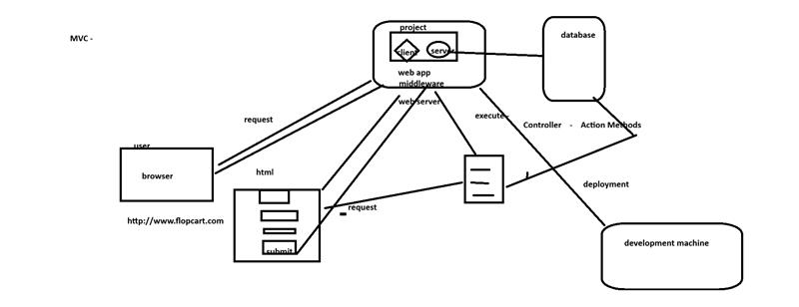
ClassNotes:
30-4-2026
================
DbFirst Migration -- Generate model and context from existing tables

add-migration ->up- down - dontet ef migration add <name>
update-databse ->will call up method- dotnet ef database update
drop-database -> will call the down to remove the tables
remove-migration - removes the migrations folder

db first migration
========
Scaffold-dbcontext "server=.\sqlexpress;initial catalog=ecommerce;integrated security=true;
trustserversecurity=true" Microsoft.EntityFrameworkCore.SqlServer
-OutputDir Models

class Bill{
[Key]
[DatabaseGenerated(DatabaseGeneratedOption.None)]
public int No{get;set;}
[Column(typename="varcahr(40)")]
public string CustomerName{get;set;}
}
public override void onModelCreateting(){ //Fluent API
modelBuilder.Entity<Bill>(i => {
i.HasKey("No");
}); // adding primary key to No column
modelBuilder.Entity<Bill>(e => {
e.Property<string>("customername").HasColumnType("varchar(34)");
}); // changing column type to varchar
=============

Web application :
Traditional -> client + server side in one project
Modern -- separate client and server projects
in dotnet this can be created using
----------------------------------
.net framework -
WebForms , MVC
dotnet 8 -
RazorPages, MVC

Model (classes that represent forms),Views(html pages),controller - business logic
================================================
Controller classes contain action methods - these methods are called when a request is being sent from client browser to the server. These action methods may receive a Model class object as parameter or returns one or collection of model class objects as output.

Scaffolding:process of generating the code automatically

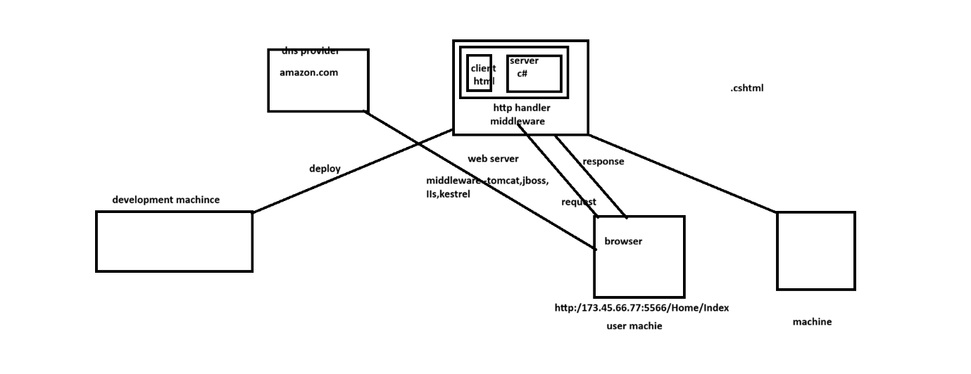
Guys Project titles are shared over the respective channel
We have to follow Agile Model so
1.identity the requirements
2.Create the Product Backlog
3.Identity the No of sprints and sprint backlogs
4.Identify the work items of each backlog
5.Create the ER Diagram of tables required
6. use Gira or Azure Dev ops to record the backlogs and work items
( atleast use excel )
7.Draw the UI Design and flow( use AdobeXd, Figma , NotebookLM etc)
Next session on Monday I will evaluate the same and make the corrections.

Scrum-Masters need to conduct group meeting to analyse requirements and assign team members to create the deliverables(i.e backlogs,er diagram etc) 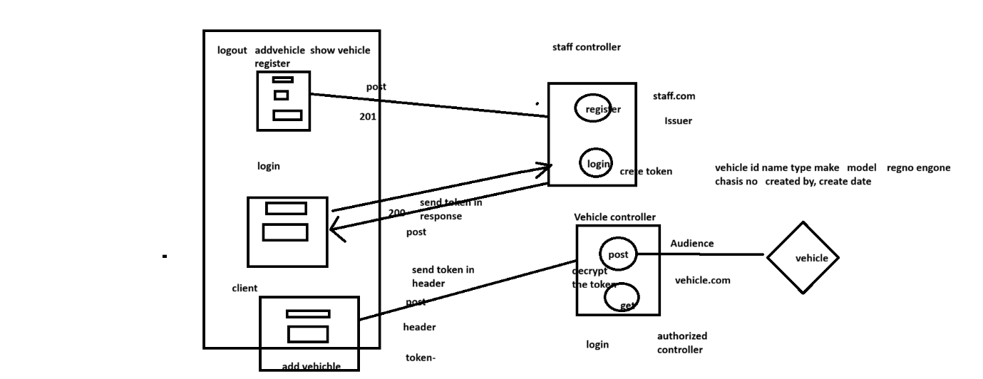
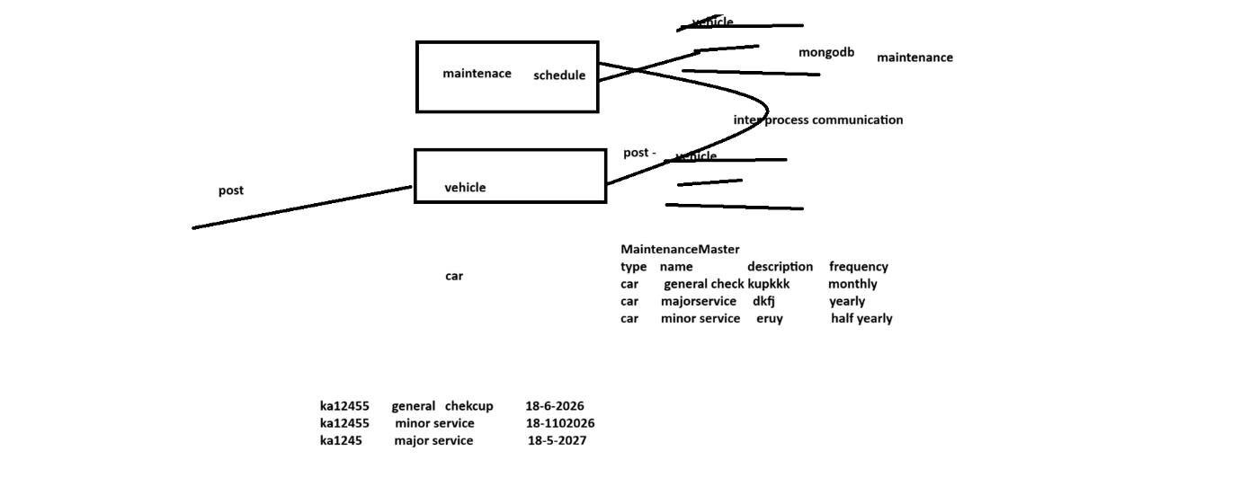
using dapper to call stored procedures
performing bulk insert using EFCore.BulkExtensions
doing inter service communication between two API's

create the required stored procedures in the respective databases

eg:
create procedure [dbo].[proc_ins_vehicle](@type varchar(40),
@model varchar(40),@regnno varchar(15),
@enginecapacity int,
@year int,
@createdby varchar(100))
as
insert into vehicles values(@type,@model,@regnno,@enginecapacity,
@year,@createdby)
Attributes - provide metadata about class,method,property etc
Reflection - code written to read and understand attribute and its values or class and its properties, methods, parameters etc.
Aspect Oriented Programming -
Aspect - cross cutting concerns (overlapping requirements)
Developing these aspects as a separate pluggable module is called Aspect Oriented Programming

ado -- package for database interaction available with visual basic language
ado.net - is package build on top of ado package for dotnet applications to interact with database.(SQLConnection,SqlDataReader,SqlCommand)
asp.net -
framework available withing dotnet sdk (provides Microsoft.Aspnet.MVC) used to develop web applications.
Entity Framework - Framework to interaction with databases.Proviedes classes named DbContext,
DbSet<> and functions like SaveChanges(),
Dapper- is a library provides a set of Extension methods to interact with database used along with ADo.net or EF.

Angular - javascript framework helps to simplify the single page application. It allows developer to use html code for dom manipulation. Event handling code need written in typescript.
Some other similar frameworks
===========================
Vue --
Ionic
Ember
React - it is a library (javascript/typescript)
Typescript - object oriented, strongly typed, is an extension of javascript.
traspilation - converting typescript to javascript
install typescript transpiler- npm install -g typescript
to convert typescript to javascript
===============
tsc <filename.ts>
eg:tsc first.ts -> will generate first.js
and run
using:- node first.js

//object oriented programming with typescript
class Patient{
id?:number;//public
private name:string='anil';
protected age?:number;
constructor(id:number,n:string,a:number){
this.id= id;
this.name=n;
this.age=a;
}
show(){
console.log(`${this.id} ${this.name} ${this.age}`);
}
}
https://www.typescriptlang.org/

<app-root> -- is a selector , behind selector a partial html,css,ts code is present.
selector - is an alias name to a component(partial html,css,ts)

an angular application is a collection components.
routing - loading components on demand/rendering component
to render a component in placeholder area - uses the selector name of the component
app component - <app-root>
custom components:- components created by the developer.
option1:create one typescript file which contains html,css,typescript(inline template)
option2: create separate html,css and typescript
to create a new component
ng generate component <name of the component>
eg: ng g c navigation
ng g c register --skip-tests - skip test file creation
@Component({
selector: 'app-register',
imports: [],
template: ` <p>register works!</p> `,
styles: ``,
})
decorator - similar to attributes c#
services,components,directives,modules(optional)

event binding - associating eventhandler functions with html template
syntax (eventname)="eventhadler()"
databinding - associate data from typescript to template
property binding-
syntax- property={{data}} - {{}} -interpolation
eg: <input placeholder={{email}}/>
[property]="variable" -- property binding syntax

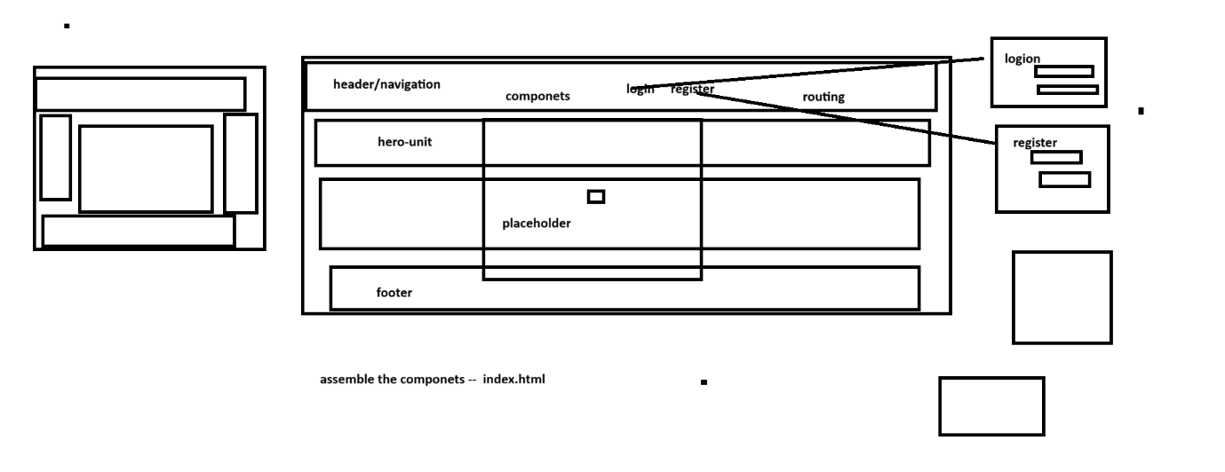
logging- serilog - actionfilters - actionfilterattribute
global exception handler - filter
gateway
discovery-
cqrs --
dtos

<div style="display: flex;">
@for( dish of dishes;track dish.id){
<div class="dish">
<img [src]="dish.image" alt="{{dish.name}}" class="dish-image" height="150px" width="150px">
<h3>{{dish.name}}</h3>
<p>Rating: {{dish.rate}}</p>
</div>
}
</div>

service class
import { Injectable } from '@angular/core';
import Dish from '../models/dish';

@Injectable({
providedIn: 'root',
})
export class DishService {
dishes:Array<Dish> = []

constructor(){
this.dishes.push(new Dish(1,'chapathis',5,'https://vegangirlsguide.com/wp-content/uploads/2024/10/egg-dish-recipe-1729253416.jpg'));
this.dishes.push(new Dish(2,'poori',4,'https://static01.nyt.com/images/2024/03/27/multimedia/20appetite-Skillet-Eggs-ltzq/20appetite-Skill…));
this.dishes.push(new Dish(3,'paratha',3,'https://www.thenewlywedpilgrimage.com/wp-content/uploads/2024/06/Eggs-Benedict-Recipe-2.jpg'));
}
getDishes():Array<Dish>{
return this.dishes;
}
}

model
export default class Dish {

constructor(public id?: number,
public name?:string,
public rate?:number,
public image?:string)
{}

}

show dishes typescript
import { Component } from '@angular/core';
import { DishService } from '../services/dishservice';

@Component({
selector: 'tomato-show-dishes',
imports: [],
templateUrl: './show-dishes.html',
styleUrl: './show-dishes.css',
})
export class ShowDishes {

dishes:Array<any> = []

constructor(public ds:DishService){
this.dishes = this.ds.getDishes();
}
}

add-dish.html
<div class="add-dish">
<h2>Add New Dish</h2>
id <input type="text"> <br>
name <input type="text"> <br>
rate <input type="text"> <br>
image <input type="text"> <br>
<button>Save</button>
</div>

<div class="add-dish">
<h2>Add New Dish</h2>
<!-- id <input type="text" [value]="d.id" (input)="idHandler($event)""> <br> -->
id <input type="text" [(ngModel)]="d.id"> <br>
name <input type="text" [(ngModel)]="d.name"> <br>
rate <input type="text" [(ngModel)]="d.rate"> <br>
image <input type="text" [(ngModel)]="d.image"> <br>
<button class="btn btn-success">Save</button>
</div>

adddish.ts
import { Component } from '@angular/core';
import Dish from '../models/dish';
import { FormsModule } from '@angular/forms';
import { DishService } from '../services/dishservice';
import { ShowDishes } from "../show-dishes/show-dishes";

@Component({
selector: 'tomato-add-dish',
imports: [FormsModule, ShowDishes],
templateUrl: './add-dish.html',
styleUrl: './add-dish.css',
})
export class AddDish {

d:Dish = new Dish(1);

constructor(private ds:DishService){}
saveHandler(){
this.ds.addDish(this.d);
this.d = new Dish();
}
}

dish service.ts
import { Injectable } from '@angular/core';
import Dish from '../models/dish';

@Injectable({
providedIn: 'root',
})
export class DishService {
dishes:Array<Dish> = []

constructor(){
this.dishes.push(new Dish(1,'chapathis',5,'https://vegangirlsguide.com/wp-content/uploads/2024/10/egg-dish-recipe-1729253416.jpg'));
this.dishes.push(new Dish(2,'poori',4,'https://static01.nyt.com/images/2024/03/27/multimedia/20appetite-Skillet-Eggs-ltzq/20appetite-Skill…));
this.dishes.push(new Dish(3,'paratha',3,'https://www.thenewlywedpilgrimage.com/wp-content/uploads/2024/06/Eggs-Benedict-Recipe-2.jpg'));
}
getDishes():Array<Dish>{
return this.dishes;
}
addDish(d:Dish){
this.dishes.push(d);
}
}

full code with dish adding and showing
if you want to test this code
- extract the file
- go inside the extracted folder(use cd command)
- type "npm install" in command prompt
- run "ng serve"
- 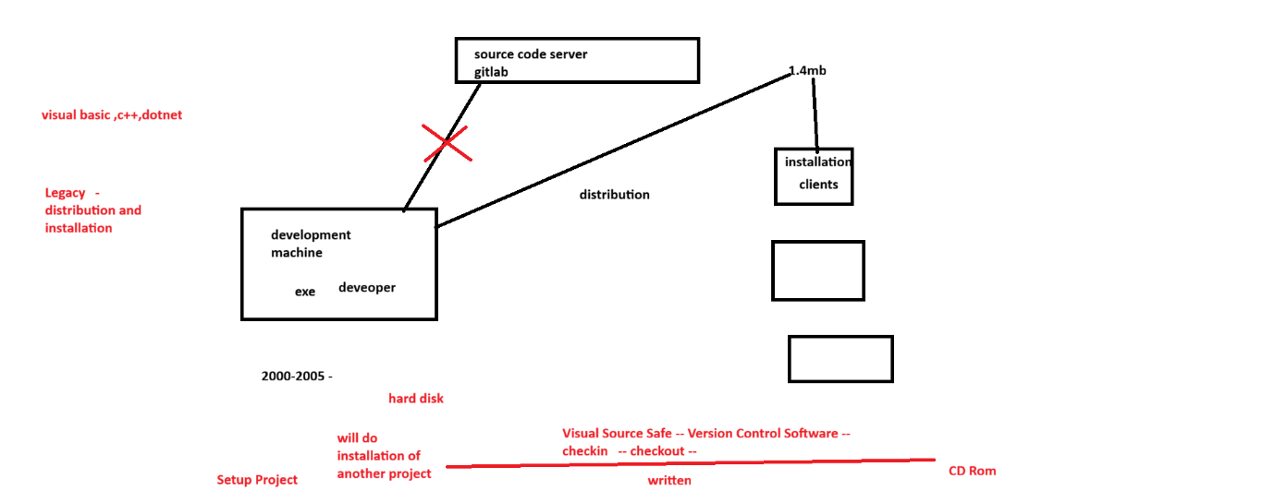
- 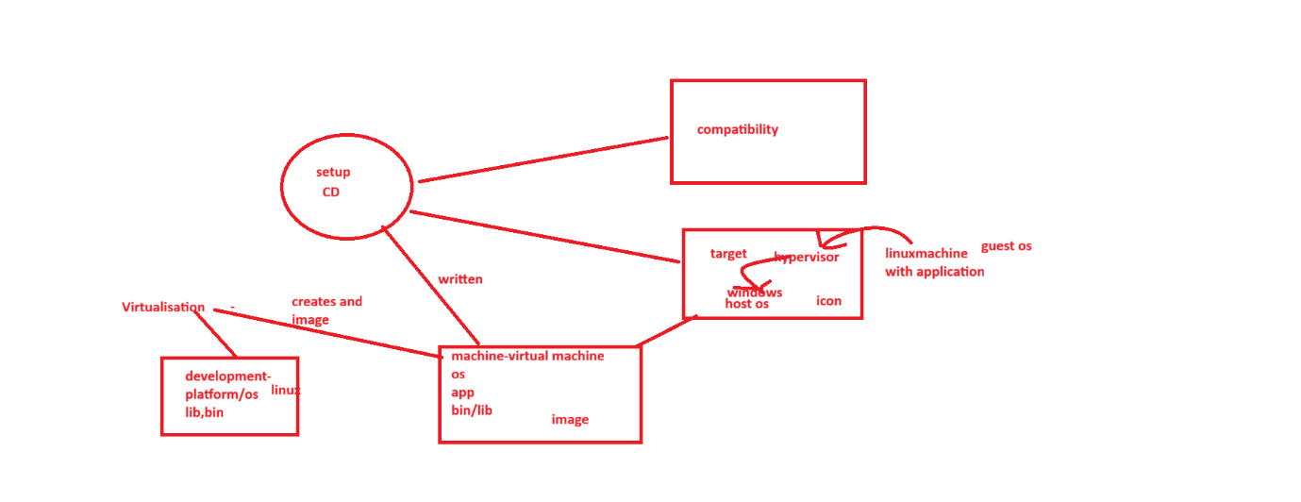
- 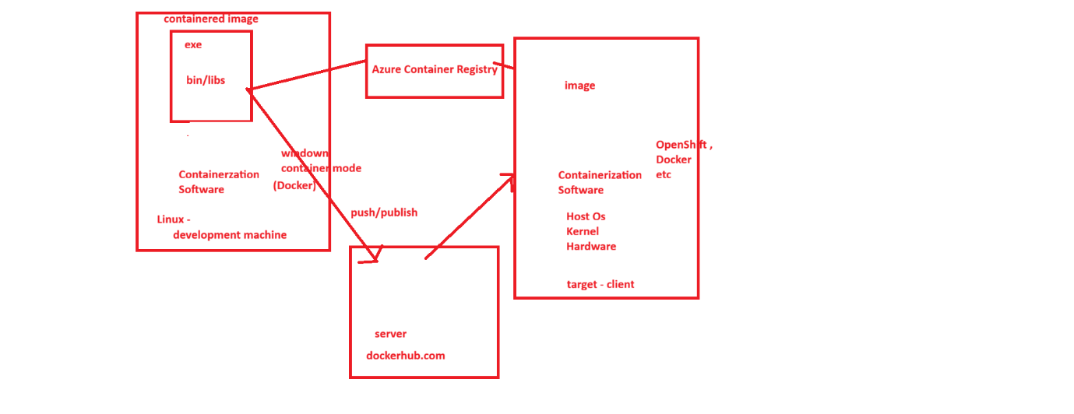

================
1-6-2026
================
agenda
--------
distributing apps and deployment/installing of apps
basics virtualisation, containerization
------------------
Legacy ways- setup project , xcopy
Virtualisation -- is a way to distribute apps. in this process of creating a virtual machine contains app+ bin+lib+os
and to run the virtual machine in the target client machine we need a hypervisor(eg:virtual box,VMWare)
hypervisor installs and run the virtualised application
types of hypervisors
---------------------
type1 - bare metal - directly interact with kernel and hardware
type2 - hosted - interact with host os
disadvantage: occupies lot of memory and disk space hence slow down the application.
------------------
containerization -- is a way to distribute application
================
Here the and app along with its bins/libs added to an image called container image.
And containerization software provides os environment in the target machine so no os layer is needed in the image thus reduces size and improves performance.

Example of containerization software, Docker, OpenShift etc

Docker Hub: a Server where docker images of apps can be stored
----------
to containerise a dotnet web app
1. Add a Dockerfile to the application root.
docker file contains docker commands(eg:copy,run,build,workdir,etc) to build the docker image of the application.
2.docker build - command to create the docker image
syntax : docker build -t<tagname> <path of the docker file>
docker build -t dotnetdockerwebapp .

to run the containerized application
command :- docker run -n <containername> <imagename>
eg: docker run -n container1 dotnetdockerwebapp

copy of the docker image running in the memory is called container-
-----------------------------------------------------------------
to pull images from docker hub
docker pull <tagname/imagename>
eg: docker pull anilthirumala/itcdocker:ver1
to see how many containers are running
c:\> docker ps
To stop a docker container
c:\> docker stop <containername/id>
eg: docker stop container1
To restart a docker container
c:\> docker start <containername/id>
eg:docker start container1
To remove the docker container from memory
c:\> docker rm <containername/id>
eg: docker rm container1
To remove a docker image from machine
docker rmi <imagename>
eg: docker rmi dotnetdockerwebapp:ver1

guys, Consul discovery demo is attached
before you run this ensure that Consul is downloaded and running
also only staff service is registered in consul registry, other services you can try adding

Ensure that procedures, views and trigger are used in project(it is cts requirement)

docker-compose.yaml
(container-orchestration)-- help to start and stop multiple containers easily

docker-compose up -- build and start all images mentioned in the compose file

docker-compose down - stops all running containers

sample docker-compose file
services:
fleetgateway:
image: ${DOCKER_REGISTRY-}fleetgateway
build:
context: .
dockerfile: FleetGateway/Dockerfile
staffservice:
image: ${DOCKER_REGISTRY-}staffservice
build:
context: .
dockerfile: StaffService/Dockerfile
vehileservice:
image: ${DOCKER_REGISTRY-}vehicleservice
build:
context: .
dockerfile: VehicleService/Dockerfile

Just have a look of these topics- some candidates got this questions
Task Parallel Library (TPL) - .NET | Microsoft Learn
Data Parallelism (Task Parallel Library) - .NET | Microsoft Learn

services -1000 plus services are avaibale in azure portal
services are classified into
1.Infrastructure as a service(iaas) -- virtual machine
2.Platform as a Service (paas) - app service
3.Software as a service(saas) -
4.Serverless (Lambda) –

import { HttpClient } from '@angular/common/http';
import { Component } from '@angular/core';
import { Slot } from '../models/slot';
import { FormsModule } from '@angular/forms';

@Component({
selector: 'app-add-slot',
imports: [FormsModule],
templateUrl: './add-slot.html',
styleUrl: './add-slot.css',
})
export class AddSlot {
s:Slot = new Slot();
constructor(private client:HttpClient ){

}

addSlot(){
this.client.post("http://localhost:5062/api/slot",this.s)
.subscribe({
next: (data) => alert(JSON.stringify(data)),
error: (error) => alert(JSON.stringify(error))
});
}
}

add-slots.html - fyr
<div>
<h2>Add Slot</h2>
Slot Code <input type="text" [(ngModel)]="s.slotcode"> <br>
Slot date <input type="text" [(ngModel)]="s.slotdate" > <br>
Slot start time <input type="text" [(ngModel)]="s.starttime"> <br>
Slot End Time <input type="text" [(ngModel)]="s.endtime"> <br>
Provider <input type="text" [(ngModel)]="s.provider"> <br>
Location <input type="text" [(ngModel)]="s.location"> <br>
<button (click)="addSlot()">Add slot</button>
</div>

import { Component, OnInit } from '@angular/core';
import { Slot } from '../models/slot';
import { HttpClient } from '@angular/common/http';
import { JsonPipe } from '@angular/common';

@Component({
selector: 'app-show-slots',
imports: [],
templateUrl: './show-slots.html',
styleUrl: './show-slots.css',
})
export class ShowSlots implements OnInit {
slots:Array<Slot> = [];
constructor(private c:HttpClient){}

ngOnInit() { //life cycle method
this.c.get<Array<Slot>>("http://localhost:5062/api/slot")
.subscribe({
next:(data)=>{ this.slots=data;},
error:(error)=>{alert(JSON.stringify(error))}
})
}
}

<h3>Slots avaibale</h3>
<table border="1">
<tr>
<td>Slotcode</td>
<td>Slotdate</td>
<td>starttime</td>
<td>end time</td>
<td>provider</td>
<td>location</td>
</tr>
@for(s of slots;track s.slotCode){
<tr>
<td>{{s.slotCode}}</td>
<td>{{s.slotDate}}</td>
<td>{{s.startTime}}</td>
<td>{{s.endTime}}</td>
<td>{{s.provider}}</td>
<td>{{s.location}}</td>
</tr>

}
</table>

add task component - emitting event and sending data
import { Component, EventEmitter, Input, Output } from '@angular/core';
import { Task } from '../models/task';
import { FormsModule } from '@angular/forms';
import { ShowTask } from '../show-task/show-task';

@Component({
selector: 'app-add-task', //<app-add-task (taskAdded)="addTask()"/>
imports: [FormsModule,ShowTask],
templateUrl: './add-task.html',
styleUrl: './add-task.css',
})
export class AddTask {
task:Task=new Task();

@Output() taskAdded:EventEmitter<Task> = new EventEmitter<Task>();

addTask(){
this.taskAdded.emit(this.task)
this.task = new Task();
}
}

app.html (parent component)
receive the emitted data and passing to the event handler function
<app-add-task (taskAdded)="receiveTask($event)"></app-add-task>
<app-show-task [tasks]="datas" ></app-show-task>

app.ts(parent)
contains event handler function which receives the event data and storing to array
import { Component, signal } from '@angular/core';
import { RouterOutlet } from '@angular/router';
import { AddTask } from './add-task/add-task';
import { ShowTask } from './show-task/show-task';
import { Task } from './models/task';

@Component({
selector: 'app-root',
imports: [RouterOutlet,AddTask,ShowTask],
templateUrl: './app.html',
styleUrl: './app.css',
})
export class App {
datas:Array<Task> = []
protected readonly title = signal('componentinteractiondemo');

receiveTask(task:Task){
this.datas.push(task);
}
}

Angular - Sharing data between child and parent directives and components

working of your projects with front end backend integration with raw ui will be reviewed tomorrow evening. Please ensure that all backend services are integrated with front end.

import { Injectable } from '@angular/core';
import { Product } from '../models/product';
import { BehaviorSubject } from 'rxjs';

@Injectable({
providedIn: 'root',
})
export class ProductService {

bs = new BehaviorSubject<Array<Product>>([])
private products:Array<Product>=[]
constructor(){
this.products.push(new Product(1,'Mouse',450));
this.products.push(new Product(2,'Laptop',49950));
this.products.push(new Product(3,'Hard Disk',4500));
}
getProducts(){
return this.bs;
}
addProduct(p:Product){
this.products.push(p);
this.bs.next(this.products)
}
}

ensure that .gitignore file is present in all local repository. otherwise un necessary files will be pushed to github

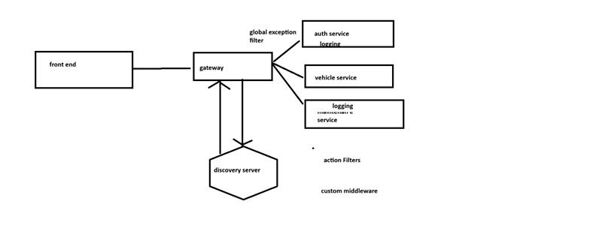
DevTools • Overview • Angular --- Angular tools for debugging( this is a separate installation, in my machine this installation is disabled)

NOTES

